Procedural Programming Languages

📌 Definition:
# Source: AI Source: Provided by: [Data Path: Persons Table -> ID Column: 1, Name_En Column: Motasem Essam] -> From: [Chatgpt (GPT‑5 Mini)] on [12/9/2025]
Procedural languages are a type of high-level programming language that focus on step-by-step instructions to solve a problem using procedures (functions).

🧠 Simple idea:
# Source: AI Source: Provided by: [Data Path: Persons Table -> ID Column: 1, Name_En Column: Motasem Essam] -> From: [Chatgpt (GPT‑5 Mini)] on [12/9/2025]
Procedural = Do this → then this → then this (step-by-step)

🔍 Key characteristics:
# Source: AI Source: Provided by: [Data Path: Persons Table -> ID Column: 1, Name_En Column: Motasem Essam] -> From: [Chatgpt (GPT‑5 Mini)] on [12/9/2025]
- ✅ Code is organized into functions/procedures
- ✅ Follows a sequence of steps (top-down approach)
- ✅ Uses variables, loops, and conditions
- ✅ Easy to understand and structure for simple tasks

🧩 Example:
# Source: AI Source: Provided by: [Data Path: Persons Table -> ID Column: 1, Name_En Column: Motasem Essam] -> From: [Chatgpt (GPT‑5 Mini)] on [12/9/2025]
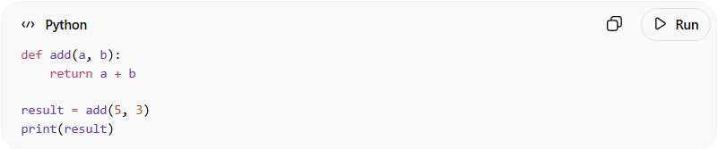
def add(a, b):
return a + b

result = add(5, 3)
print(result)
👉 Steps are executed one after another.

⚙️ How it works:
# Source: AI Source: Provided by: [Data Path: Persons Table -> ID Column: 1, Name_En Column: Motasem Essam] -> From: [Chatgpt (GPT‑5 Mini)] on [12/9/2025]
- Break problem into smaller steps
- Write functions for each step
- Execute them in order

🆚 Procedural vs Other Paradigms
# Source: AI Source: Provided by: [Data Path: Persons Table -> ID Column: 1, Name_En Column: Motasem Essam] -> From: [Chatgpt (GPT‑5 Mini)] on [12/9/2025]
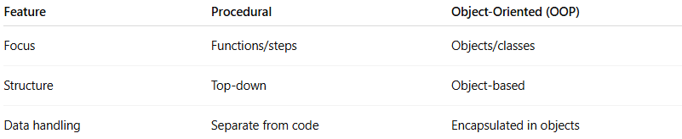
Feature | Procedural | Object-Oriented (OOP)
Focus | Functions/steps | Objects/classes
Structure | Top-down | Object-based
Data handling | Separate from code | Encapsulated in objects

🧩 Examples of Procedural Languages:
# Source: AI Source: Provided by: [Data Path: Persons Table -> ID Column: 1, Name_En Column: Motasem Essam] -> From: [Chatgpt (GPT‑5 Mini)] on [12/9/2025]
- C
- Pascal
- BASIC

✅ Summary:
# Source: AI Source: Provided by: [Data Path: Persons Table -> ID Column: 1, Name_En Column: Motasem Essam] -> From: [Chatgpt (GPT‑5 Mini)] on [12/9/2025]
Procedural programming solves problems by breaking them into a sequence of clear, step-by-step instructions using functions.

